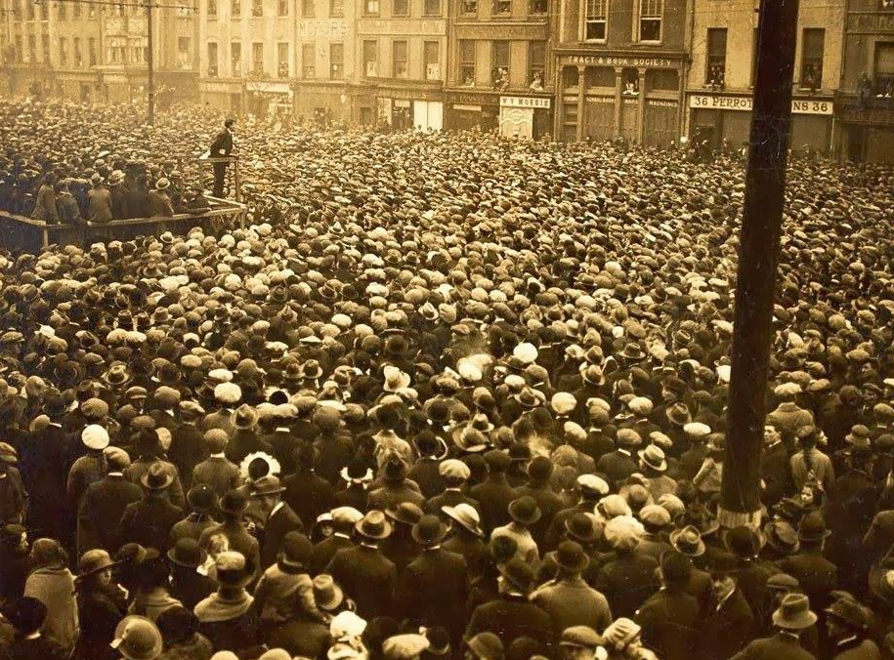

Michael Collins speaking in Cork City 1922

Commemorations Fund 2023
Cork City Council

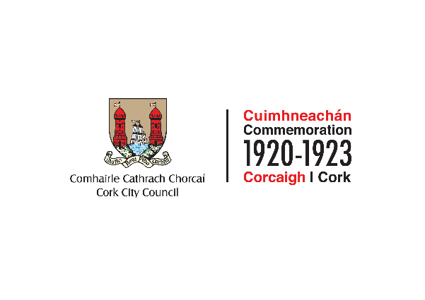
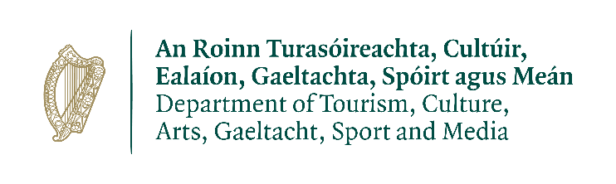

2023 COMMEMORATION FUND
As we come to the end of the Decade of Centenaries, Cork City Council are seeking applications to fund projects that reflect the pride in Cork and its people and the roles they played in the events of 100 years ago. Cork played a pivotal role in the country’s War of Independence and subsequent Civil War. The 2023 Commemorations fund will support local groups, schools, organisations and individuals to commemorate and leave a legacy that will mark the significant local events across the city.

Objectives
The objectives of the City Council’s programme are as follows:

- Re-affirm the importance of Dáil Éireann, and the ideals and principles of the men and women who played their part in the events of 100 years ago.
- Reflect pride in Cork and its people and the roles they played in the events of 100 years ago, pride in the Fire Brigade and their heroic efforts, and their resilience in rebuilding their city.
- Honour the courage of the so-called ‘ordinary’ people who took part in the struggle, and their perseverance in the face of adversity.
- Honour the reasons why they took part in the struggle and continue to seek to bring about the type of Ireland the Volunteers envisaged – equality, fairness, women’s rights, access to jobs and homes, and so on.
- Respect the past with an eye to the future, and examine events in the context of the time in which they happened.
- Recognize that history is not black and white, that stories most be told from all sides to allow for reconciliation and healing, and that the trauma of the period needs to be addressed, perhaps through the schools as an educational programme on the effects of conflict.
- Take care and time so that everyone feels welcome to be present at, and contribute to these events

Themes
Projects could be covered under the broad themes listed below as per the National Commemoration Programme. These themes are offered to help develop initiatives and projects and encourage flexibility, community engagement and creative interpretations. Examples of themes below.

- Community-led commemoration and reflection; Remembering local legacies, personalities, places, events, and themes that have particular significance within counties, parishes, and communities.
- Respectful, sensitive, and non-partisan remembrance of all of those who suffered and died during the period from 1922-1923.
- The partitioning of Ireland – exploration of the impact and legacy of the events that occurred during this period on communities living along the newly established border and further afield.
- Ireland and the Wider World – exploration of the international dimension, including local connections, emigration, and the role of the Irish Diaspora in the events that occurred during the revolutionary period. Also, exploration of the evolution of all-island institutions following partition.
- Experiences of women - exploration of the experiences of women during this period and their contribution to the events that occurred, including their changing role in society.
- Establishing a New Order – Rebuilding the City
- Exploration of the significance of local government reform and the evolution of new political and administrative structures at national and local level;
- Including the establishment of the various institutions of the Irish Free State (including Civil Service, the Defence Forces, An Garda Síochána, judiciary, and courts services);
- Development of new infrastructure (transportation, communications, postal services);
- Continuing the parliamentary tradition – an exploration of the prominent personalities and local issues associated with elections during this period, e.g. the 1922 and 1923 general elections.
- Looking ahead to the process of rebuilding a nation – reflections on healing, repairing and rebuilding after the Civil War – of people, communities, and places.
- A Changing Society during this period, including: The labour movement and civil disobedience; Popular social, cultural and civic movements; Social class and gender; The Irish language; The Land Question; The significance of sport in communities during this period; The humanitarian response during the period 1921 – 1923; The experiences of people in Ireland during this period who would today identify as part of the LGBTQ+ community; The experiences of minority ethnic groups in Ireland during this period; Innovation and developments in the fields of agriculture, industry, science, commerce, health, medicine, and education.
- Creative thinking and the arts – poetry, literature, music, theatre, and other art forms, 1921 – 1923. Potential initiatives could include (but not limited to) Initiatives such as films, podcasts, exhibitions, performances; Artistic commissions; Artist, writer, poets in residence programmes; Creative writing programmes; Art competitions; Initiatives that support engagement with older people, new communities, young people etc; Use of digital media

Eligibility
All projects will be considered, taking note that the following activities are not eligible for funding from this allocation:
- Provision or maintenance of memorials, plaques, busts, or statues;
- Hiring or purchase of replica weapons or uniforms and military re-enactments;
- Production of commemorative medals or pins;
- General administration outside of the scope of the Decade of Centenaries Programme and other activities unrelated to the thematic strands of the programme; and
- Commercial activities.

Projects should publicly acknowledge Cork City Council in all communications and materials concerning activities supported by this grant funding. Cork City Council should be tagged on any related social media activity. The Commemorations team will be able to assist you with this.

Successful applications for funding will only be paid to the applicant organisation’s Bank Account. Please ensure you have your Bank Account details to hand if your application is successful.

__________________________________________________________________________________
ALL APPLICATIONS ARE TO BE RETURNED TO:
Karen Fitzgerald, Corporate Affairs and International Relations, Cork City Council, Floor 3, New Civic Offices, City Hall, Cork or emailed to commemorations@corkcity.ie by 4pm, Friday 10th February.
The closing date will be strictly adhered to.

Application Form
All questions on this form must be answered. Please write your answers clearly in block letters. This form is available as a PDF or Word document – please include any relevant details as appropriate.

Your Organisation
Name of Group/Organisation
Address (incl Eircode)
Contact Name |  | Alternative  Contact name
Email |  | Alternative  E-mail
Telephone number |  | Alternative Telephone number
Website |  | Chairperson
Secretary |  | Treasurer
Is your group a member of the Public Participation Network (PPN) |  |  | Yes No
Please provide a brief organisational description of your group/organisation e.g., committee structure, meeting schedule etc.

What is the purpose of the group/organisation?

Project Details

All initiatives and activities funded must adhere to all of the public health advice and guidance, laid down by the HSE and the Government, with regard to the COVID-19 pandemic.
Outline details of your project

What will the funding be used for? Note: give examples of types of expenditure

How does your organisation link with other organisations in your area?

Is this part of a phased project and/or linked with (or funded by) other schemes operated by Government Departments or Cork City Council? If yes, please give details below

When will your project begin? | When will your project be completed? | Charitable Status Number (if applicable) | Tax Reference Number (if applicable) | Tax Clearance Access Number (if applicable)

Funding

Amount being applied for under this fund: | €
Did you receive funding in 2020, 2021 or 2022?
If yes, please give details including amounts received.

Is this amount partial or total project cost | Partial Total
If partial, give estimated total project cost | €
To be eligible for funding under this programme you must state where you will source any shortfall of funding. Please provide these details below (add extra rows if required) | Source | Amount
Has or will your organisation avail of other funding from Cork City Council or other government departments for this project? If yes, please give details

Please state how your group proposes to publicly acknowledge Cork City Council

Declaration

- I declare that the information given in this form is correct.

- I confirm that the applicant group/organisation does not have the funding to undertake the work/project without this grant aid or alternatively that the grant will facilitate a larger project which they would otherwise be unable to afford.

- I confirm that the applicant group/organisation is tax compliant (if tax registered).

- I confirm that the applicant group/organisation will comply with all relevant public health guidelines

Name (on behalf of group/organisation)
Signature if completing and returning this form digitally, you can sign it later if successful.
Position held in group/organisation
Date
OFFICE USE ONLY
Date received
Reference number

__________________________________________________________________________________
ALL APPLICATIONS ARE TO BE RETURNED TO:
Karen Fitzgerald, Corporate Affairs and International Relations, Cork City Council, Floor 3, New Civic Offices, City Hall, Cork or emailed to commemorations@corkcity.ie by 4pm, Friday 10th February.
The closing date will be strictly adhered to.

Public Participation Network It is not a requirement to be a member of the PPN to receive this grant. If you'd like to learn more about the Public Participation Network, please contact Cork City Public Participation Network Tel 085 1344 605 info@corkcityppn.ie Alternatively you can complete a membership form online.

