Idirghníomhaireachta um Bainistíocht Éigeandála, Urlár1, An tOspidéil Súl, Cluas agus Scornaí, Bóthar An Iarthair, Corcaigh, ÉireT12 WP62

Inter-Agency Emergency Management Office, Floor 1, Eye, Ear & Throat Hospital, Western Road, Cork, Ireland T12 WP62

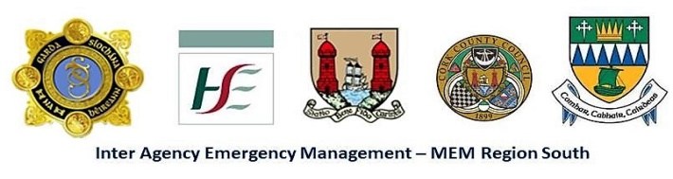
Tel. / Teil: +353 21 - 49 21621 / 49 21690; Fax / Facs: 021 - 49 21627; Email / r-phost: info@iaemo.ie
_________________________________________________________________________
Public Notice Under S.I. no. 209 of 2015 Chemicals Act (Control of Major Accident Hazards involving Dangerous Substances)

Public consultation of the draft External Emergency Plan for Upper Tier COMAH site
Grasslands Agro
Carrigrohane Road Cork T12 AY97

will take place from 9th November 2020 to 4th December 2020 inclusive, excluding weekends.

Due to Public Health guidelines and COVID 19 restrictions to make arrangement to view a draft copy of the External Emergency Plan for Grasslands Agro

- Email the Inter Agency Emergency Management Office info@iaemo.ie detailing if you require a hard copy or electronic copy of the draft plan
OR
- Telephone the Inter Agency Emergency Management Office 021 4921690 to request an electronic or hard copy of the draft Plan
The Inter Agency Emergency Management Office is staffed from 0930hrs to 1630hrs Monday to Friday.
Note that the closing time and date for submissions is 17:00 hrs. on 4th December 2020 .

A feedback form, which may be used to make a submission, will be provided with the draft plan.
If you require further information on the above, please contact:

Regional Working Group for Major Emergency Management
C/O Inter-Agency Emergency Management Officer, HSE South, Eye, Ear & Throat Hospital, Western Road, Cork T12 WP62

Telephone no.: 021-492 1690 / 492 1621
Email address: info@iameo.ie

