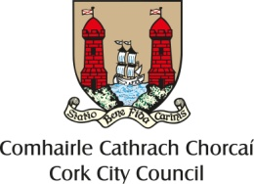 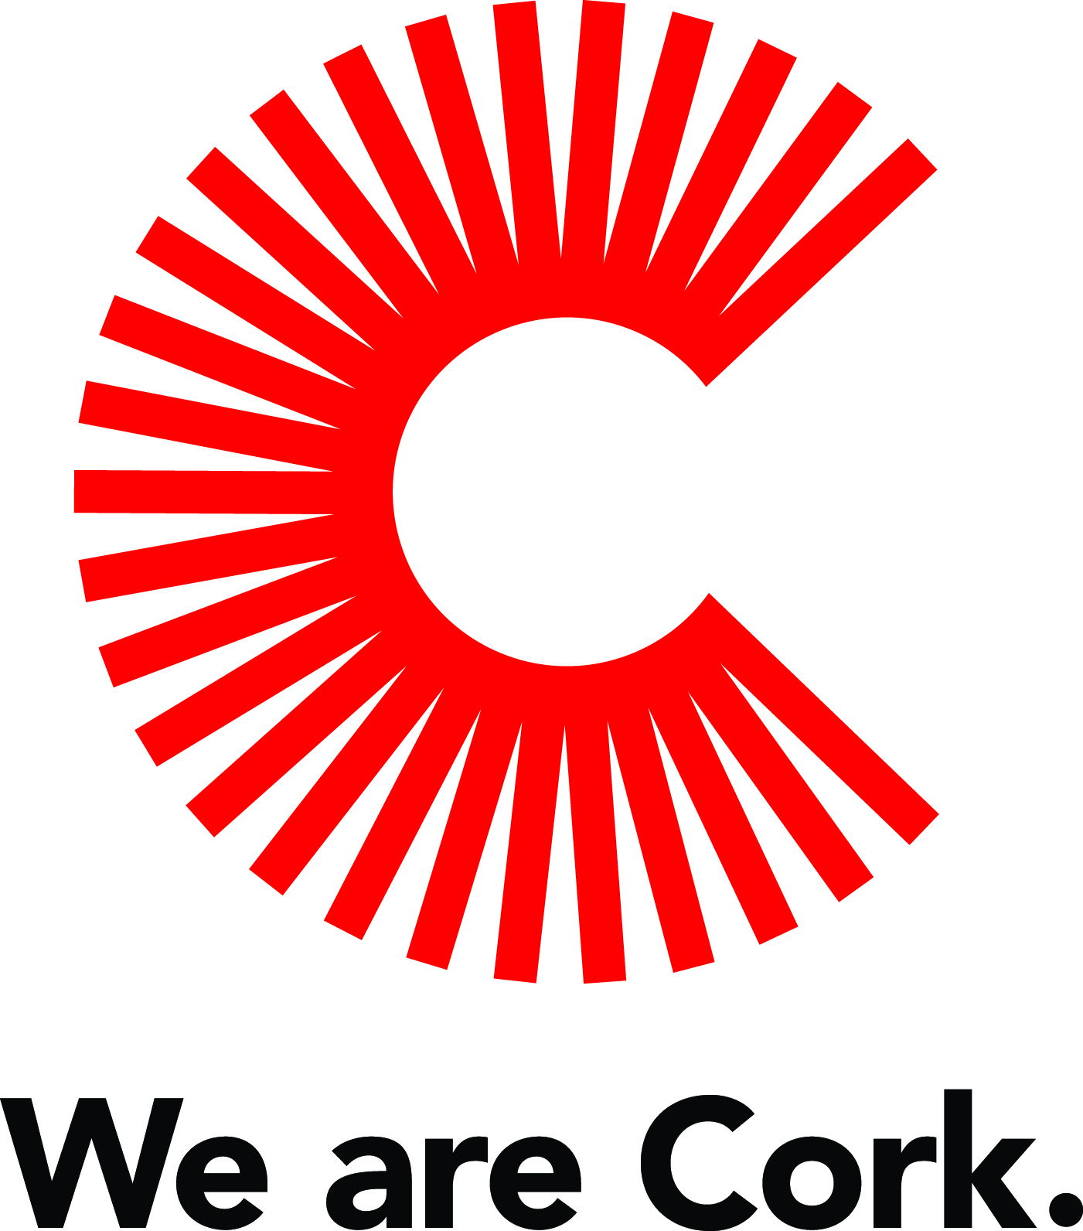

**Cork City Centre Placemaking Fund 2019**

**Overall Aim:** Supportprojects which will enhance, improve, and enliven people’s experience of cork city centre

We are looking for projects which improve public space, inspire visitors and enhance the city centre experience, increase footfall and support the local economy.

We aim to support the customer/visitor experience movement in the city centre and to encourage collaboration.

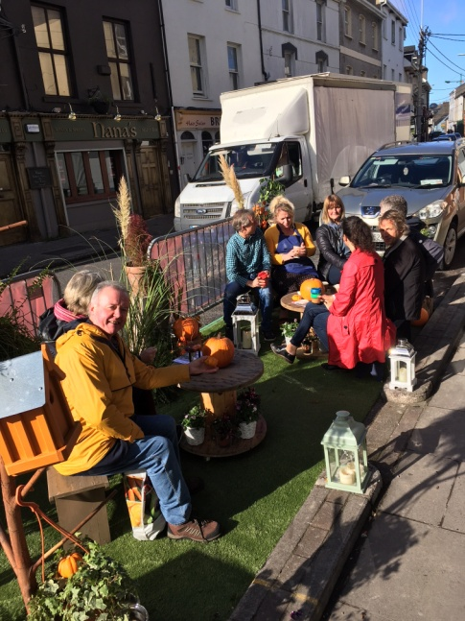 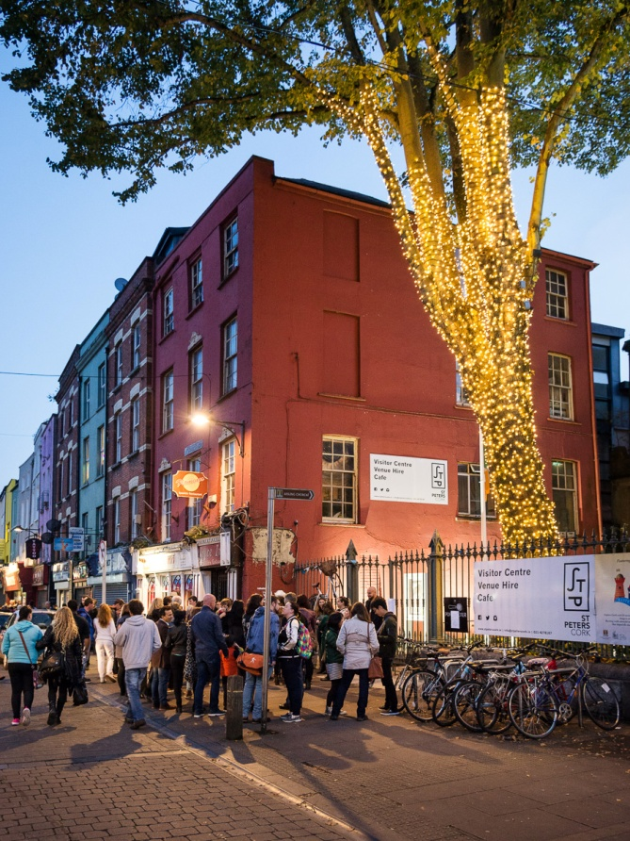

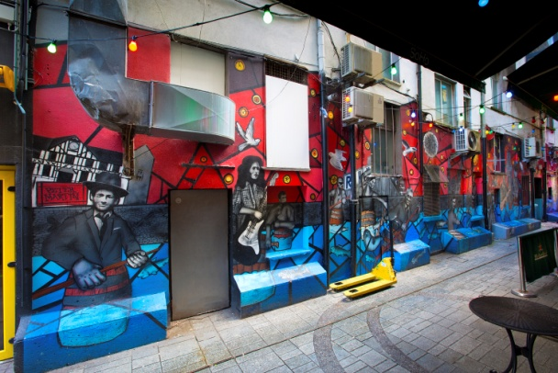

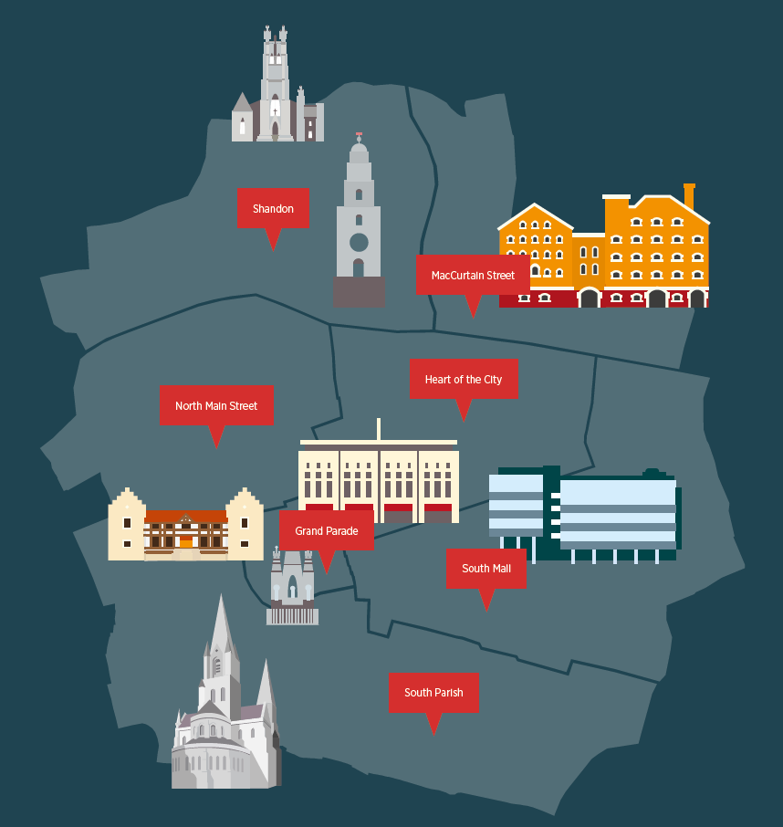 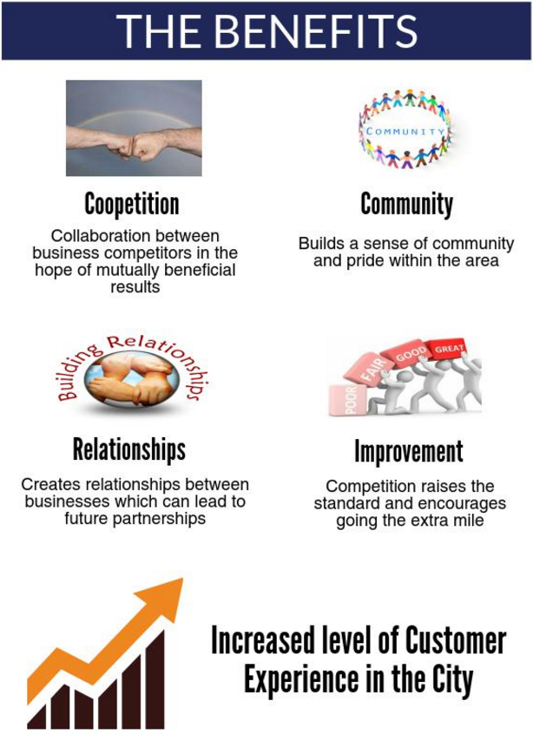

**Project must deliver one or more of the following outcomes:**

• Improved physical appearance of a street/area

• An improved visitor/resident experience through attractions and interactions

• Improved working partnerships / networks within the city centre between businesses, residents and local communities

• Creation or enhancement of public space which encourage people to stay in the city centre longer, increase community use and engagement, increase footfall, or increase spend in the city centre

**Potential Projects**

* Murals or cultural/artistic attractions
* Greening/environmental improvement projects
* Atmospheric lighting
* Unique events which increase liveliness of streets

* Creative public seating, parklets
* Other projects which enhance residents/visitors experience of the city centre or particular streets/areas

**The Fund**

We will fund up to **€10,000** towards the cost of an individual project (although many projects may require much less). It will be Cork City Council’s decision on how much is contributed based on the scheme’s objectives. This is primarily a capital fund, although events are also eligible if considered unique and contribute significantly towards the fund’s objectives.

**Assessment Criteria & Eligibility**

1 - Evidence of need for the project and how this particular project will address the need

2 - Evidence of community and business engagement and support for the project

3 - Evidence of the project’s contribution towards supporting the city centre, the local

economy and the benefits it will bring

4 – Evidence of a well costed and thought through project

5 - Evidence of the projects sustainability following completion

6 – Alignment of the application to the City Centre Strategy/action plan

To be eligible the project (and organisation) must

O Be in Cork City Centre (as defined by City Centre Strategy)

o Lease, own or have written permission from the owner of the land or building where they

wish to carry out a project

o Deliver the project within 12 months of receiving funds

o Contribute to the scheme’s objectives

o Have any necessary permissions, consents or licenses in place required to deliver the

project

o Have insurance and public liability for the delivery of the project

o Comply with any relevant Health and Safety regulations

**Who can apply?**

Business Network Groups or Community Groups operating within the city centre

For informal enquiries or to discuss further please email [paul_mcguirk@corkcity.ie](mailto:paul_mcguirk@corkcity.ie) or telephone 021 4924773