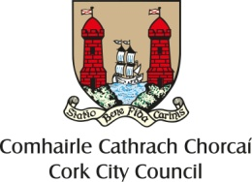

Cork City Centre Placemaking Fund 2020

Overall Aim: Support projects which will enhance, improve, and enliven people’s experience of cork city centre

We are looking for projects which improve public space, inspire visitors and enhance the city centre experience, increase footfall and support the local economy.

We aim to support the customer/visitor/resident experience movement in the city centre and to encourage collaboration.
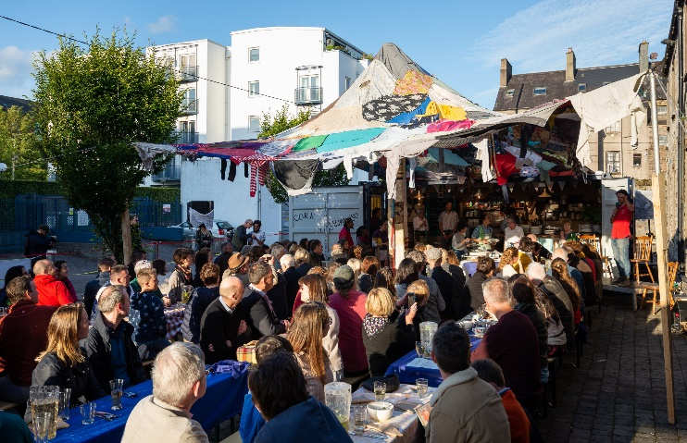
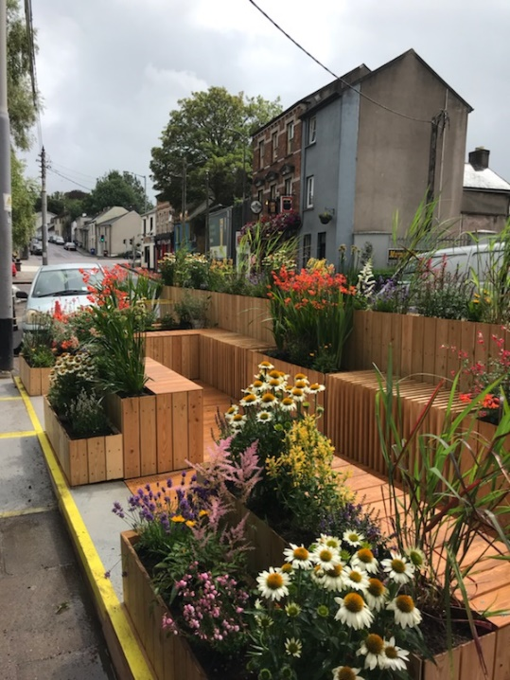
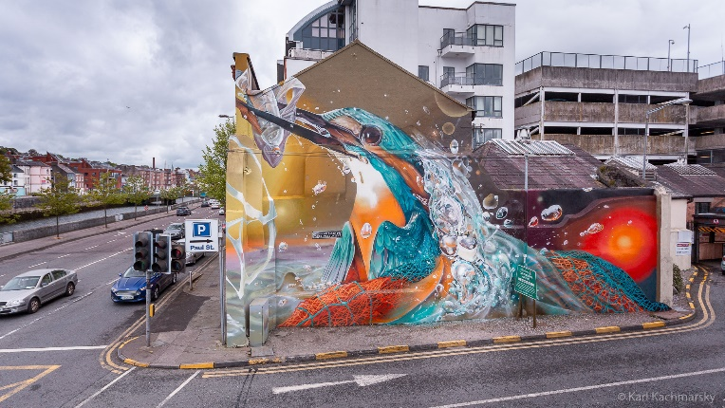
Images from some sample 2019 projects
Project must deliver one or more of the following outcomes:

• Improved physical appearance of a street/area

• An improved visitor/resident experience through attractions and interactions

• Improved working partnerships / networks within the city centre between businesses, residents
and local communities

• Creation or enhancement of public space which encourage people to stay in the city centre
longer, increase community use and engagement, increase footfall, or increase spend in the city
centre

Potential Projects
- Greening/environmental improvement projects

- Atmospheric lighting

- Murals or cultural/artistic attractions

- Unique events which increase liveliness of streets

- Creative public seating, parklets

- Other projects which enhance residents/visitors experience of the city centre or particular streets/areas

The Fund
We will fund up to €10,000 towards the cost of an individual project (although many projects may require much less). It will be Cork City Council’s decision on how much is contributed based on the scheme’s objectives. This is primarily a capital fund, although events are also eligible if considered unique and contribute significantly towards the fund’s objectives.
Assessment Criteria & Eligibility
1 - Evidence of need for the project and how this particular project will address the need
2 - Evidence of community and business engagement and support for the project
3 - Evidence of the project’s contribution towards supporting the city centre, the local
economy and the benefits it will bring
4 - Evidence of a well costed and thought through project
5 - Evidence of the projects sustainability following completion
6 - Alignment of the application to the City Centre Strategy/action plan

To be eligible the project (and organisation) must
O Be in Cork City Centre (as defined by City Centre Strategy)
o Lease, own or have written permission from the owner of the land or building where they
wish to carry out a project. This includes relevant Cork City Council directorate where relevant.
o Deliver the project within 12 months of receiving funds
o Contribute to the scheme’s objectives
o Have any necessary permissions, consents or licenses in place required to deliver the
project in advance
o Have sufficient insurance and public liability for the delivery of the project
o Comply with any relevant Health and Safety regulations

Who can apply?
Business Network Groups or Community Groups operating within the city centre

Application Form
Please read Assessment Criteria and Eligibility above before completing this application form.

A separate sheet may be attached with additional information if required.

Closing date for first round of applications is Monday, 24th February, 2020

Section A: CONTACT DETAILS

Name of Group: ………………………………………….................................................................................

Address: …………………………………………………………………………….…………..............................................

.............................................................................................................................................................................

Name of Contact Person: .......……………….…….………….……..…………….….................................................

Telephone: ......................................... Email address: ...................................................

Position Held in Group: ....................................................................................................................................

Section B: DETAILS OF PROJECT/ACTIVITY SEEKING FUNDING

Name of Project/Activity: ……………….................................................................................................................

Area that will benefit from the Project/Activity:
.............................................................................................................................................................................
.............................................................................................................................................................................

Details of project/activity: (Please state the purpose for which the funding is required and start and end date of project) .............................................................................................................................................................................
.............................................................................................................................................................................
.............................................................................................................................................................................
.......................................................................................................................................................................................................................................................................................................................................................................................................................................................................................................................................
.............................................................................................................................................................................
………………………………………………………………………………………………...........................................................................
.............................................................................................................................................................................
.............................................................................................................................................................................
.......................................................................................................................................................................................................................................................................................................................................................................................................................................................................................................................................
.............................................................................................................................................................................
.......................................................................................................................................................................................................................................................................................................................................................................................................................................................................................................................................
Details of how the project will be sustained and maintained after completion
.............................................................................................................................................................................
..........................................................................................................................................................................................................................................................................................................................................................

Section C: DETAILS OF EXPENDITURE, FUNDING REQUIRED and OTHER INCOME

EXPENDITURE: Please give a full breakdown of the project costs. Include details of activity, equipment and materials to be funded (please attach quotes if relevant):
.......................................................................................................................................................................................................................................................................................................................................................................................................................................................................................................................................
.............................................................................................................................................................................
.......................................................................................................................................................................................................................................................................................................................................................................................................................................................................................................................................

FUNDING REQUIRED:
Total cost of project: €......................................

Amount of PROJECT Grant sought from Cork City Council: €.......................................

Other Income for project: €................................
Source.................................................................................

Section D: DETAILS OF GROUP/ORGANISATION
Explain briefly what your group/organisation does: ...........................................................................................................
.............................................................................................................................................................................
.............................................................................................................................................................................
Explain how your organisation links with other organisations in your area and in the city centre
............................................................................................................................................................................
.............................................................................................................................................................................
.............................................................................................................................................................................

Acknowledgment of Cork City Council’s contribution to the funding of a project will be required in any publicity associated with the project.
Signature of Applicant on behalf of the GROUP:
Name: ....................................................................................................... Date: ..................................
Office held: ……………………………..............………………..……………......................................................
Please complete this form fully, attach all required documentation and return by 24th February 2020
Donal Guerin
Strategic Planning & Economic Development Section
Cork City Council, City Hall Cork, 021 2389 856
or email to Donal_guerin@corkcity.ie (must be under 5mb)

An optional information session for interested groups will be held on Monday, January 20th at 2.30p.m. in the Multimedia room, City Hall. To book a place please email donal_guerin@corkcity.ie

