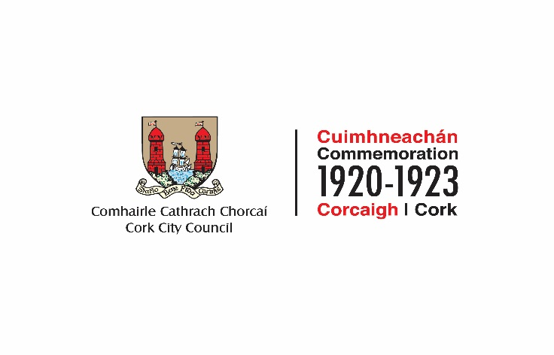

2022 COMMEMORATION FUND
NOTE: Closing Date Monday 31st January, 2022

GROUP /ORGANISATION NAME:

ALL APPLICATIONS ARE TO BE RETURNED TO:

Nicky Carroll, Corporate Affairs and International Relations
Cork City Council, Floor 3, New Civic Offices, City Hall, Cork

Or emailed to
lord_mayor@corkcity.ie
By 4pm on Monday, 31st January 2022 CLOSING DATE WILL BE STRICTLY ADHERED TO.

All questions on this form must be answered. Please write your answers clearly in block letters.

SECTION 1 – YOUR ORGANISATION

Name of Group / Organisation
Address (Correspondence will issue to this address)

Eircode
Contact name

Role in Group/Organisation

Telephone number

E-mail

Website

Alternative Contact name

Alternative Telephone number

Alternative E-mail

Please provide a brief organisational description of your group / organisation e.g. committee structure, meeting schedule etc.

Chairperson ________________________________________________
Secretary __________________________________________________
Treasurer __________________________________________________

Has your Organisation / Group registered with the relevant local Public Participation Network (PPN)?
YES ☐ NO ☐

If NO, then perhaps you would consider joining the PPN. Year established
What is the purpose of group / organisation ________________________________________________
____________________________________________________________________________________________________________________________________________________________________________________________________________________________________________________________________________________________________________________________________________________________

SECTION 2 – Project Details

The following activities are not eligible for funding;

- Provision or maintenance of memorials, plaques, busts, or statues;
- Hiring or purchase of replica weapons or uniforms;
- Production of commemorative medals or pins;
- Commercial activities.

All initiatives and activities funded must adhere to all of the public health advice and guidance, laid down by the HSE and the Government, with regard to the COVID-19 pandemic.

PURPOSE OF FUND

What will the funding be used for?
Note: give examples of types of expenditure

____________________________________________________________________________________________________________________________________________________________________________________________________________________________________________________________________________________________________________________________________________________________________

What is the purpose of the fund? (Outline details of the project).

_____________________________________________________________________________________________________________________________________________________________________________________________________________________________________________________________________________________________________________________________________________________________________________________________________________________________________________________________
When will your project begin?

When will your project be completed?

Successful applications for funding will only be paid to the applicant organisation’s Bank Account. Please ensure you have your Bank Account details to hand if your application is successful.

How does your organisation link in with other organisations in your area?

______________________________________________________________________________________________________________________________________________________________________________________________________________________________________________________________________________________________________________________________________________________________________________________________________________________________________________
Charitable Status Number (if applicable):

Tax Reference Number (if applicable):

Tax Clearance Access Number (if applicable):

Is this part of a phased project and/or linked with (or funded by) other schemes operated by Government Departments or Cork City Council?

YES ☐ NO ☐

If YES please provide the details below:

_____________________________________________________________________________________________________________________________________________________________________________________________________________________________________________________________________________________________________________________________________________________________________________________________________________________________________________________________

FUNDING

Did you receive funding in 2020 or 2021 Yes/No

If Yes please supply amount funded _________________

Amount being applied for under this fund: | €
Is this amount partial or total project cost: | - Partial | - Total
If partial, give estimated total project cost: | €

To be eligible for funding under this programme you must state where you will source any shortfall of funding. Please provide these details below.

Source | Amount

Has or will your organisation avail of other funding from Cork City Council for this project?
YES ☐ NO ☐

If YES, please give details:______________________________________________________________
________________________________________________________________________________________________________________________________________________________________________________________________________________________________________________________________________________________________________________________________________________________________

Please state how your group proposes to publicly acknowledge Cork City Council

________________________________________________________________________________________________________________________________________________________________________________________________________________________________________________________________________________________________________________________

SECTION 3 - DECLARATION

  - I declare that the information given in this form is correct.

  - I confirm that the applicant group/organisation does not have the funding to undertake the work/project without this grant aid or alternatively that the grant will facilitate a larger project which they would otherwise be unable to afford.
  - I confirm that the applicant group/organisation is tax compliant (if tax registered).

  - I confirm that the applicant group/organisation will comply with all relevant public health guidelines

Name in block capitals (on behalf of group / organisation):
Signature:
Position held in group / organisation (block capitals):
Date:

PLEASE NOTE THAT INCOMPLETE APPLICATIONS OR LATE APPLICATIONS WILL NOT BE CONSIDERED.
FOR OFFICE USE ONLY

Date Received: Reference Number:

