Idirghníomhaireachta um Bainistíocht Éigeandála, Urlár1, An tOspidéil Súl, Cluas agus Scornaí, Bóthar An Iarthair, Corcaigh, ÉireT12 WP62

Inter-Agency Emergency Management Office, Floor 1, Eye, Ear & Throat Hospital, Western Road, Cork, Ireland T12 WP62

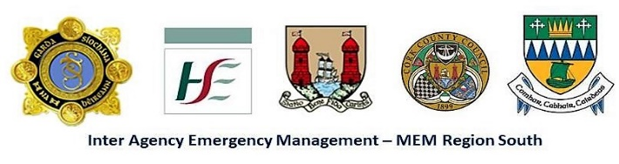
Tel. / Teil: +353 21 - 49 21621 / 49 21690; Fax / Facs: 021 - 49 21627; Email / r-phost: info@iaemo.ie
_________________________________________________________________________
Public Notice Under S.I. no. 209 of 2015 Chemicals Act (Control of Major Accident Hazards involving Dangerous Substances)

Public consultation of the draft External Emergency Plan for Upper Tier COMAH site
Calor Tivoli
Tivoli Industrial Estate Cork T23 YK27

will take place from Thursday 18th November 2021 to Thursday 16th December 2021 inclusive, excluding weekends.

The External Emergency Plan for Calor Tivoli is available to view at the following locations between 0930hrs and 1630hrs from Thursday 18th November 2021 to Thursday 16th December 2021 inclusive

- An Garda Síochána, Togher Garda Station, Tramore Road, Cork T12 YF34
- Health Service Executive, Emergency Management, Eye, Ear and Throat Hospital, Floor 1, Western Road, Cork T12 WP62.
- Cork City Fire Brigade HQ, Anglesea Street, Cork, T12 DK52
OR
- Telephone the Inter Agency Emergency Management Office 021 4921690 to request an electronic or hard copy of the draft Plan
The Inter Agency Emergency Management Office is staffed from 0930hrs to 1630hrs Monday to Friday.
Note that the closing time and date for submissions is 17:00 hrs on Thursday 16th December 2021.

A feedback form, which may be used to make a submission, will be provided with the draft plan and is attached to this notice
If you require further information on the above, please contact:
Regional Working Group for Major Emergency Management
C/O Inter-Agency Emergency Management Officer, HSE South, Eye, Ear & Throat Hospital, Western Road, Cork T12 WP62
Telephone no.: 021-492 1690 / 492 1621 Email address: info@iaemo.ie

